**E-PROJECT**

**GROUP MEMBERS** **SUBMITTED TO**

eProjects@aglsm.com

**Student Name:** Honey Motwani

**Student ID:** STUDENT1595615

**Student Name:** Faiza Aslam

**Student id:** STUDENT1595609

**Student Name:** Sassui Suhana

**Student ID:** STUDENT1595618

**Student Name:** Avinash Kumar

**Student id:** STUDENT1595622

**PROJECT INSTRUCTOR**

Sir Arbaz Hussain

**CURRICULUM CODE**

**7062**

**Index**

1. **Problem statement……………………….3**
2. **Task sheet………………………………...5**
3. **Site Map…………………………………...6**
4. **User Interface…………………………….7**
5. **Tools………………………………………17**

1 **Problem Statement**

The **Olympics** are the leading international sporting events featuring summer and winter sports competitions in which thousands of athletes from around the world participate in a variety of competitions. The Olympic Games are considered the world's foremost sports competition with more than 200 nations participating. The Olympic Games are normally held every four years, alternating between the Summer and Winter Olympics every two years in the four-year period.

The Olympic Movement consists of international sports federations (IFs), National Olympic Committees (NOCs), and organizing committees for each specific Olympic Games. As the decision-making body, the IOC is responsible for choosing the host city for each Games, and organizes and funds the Games according to the Olympic Charter. The IOC also determines the Olympic program, consisting of the sports to be contested at the Games. There are several Olympic rituals and symbols, such as the Olympic flag and torch, as well as the opening and closing ceremonies. Over 14,000 athletes competed at the 2016 Summer Olympics and 2018 Winter Olympics combined, in 35 different sports and over 400 events. The first, second, and third-place finishers in each event receive Olympic medals: gold, silver, and bronze, respectively.

The Games have grown so much that nearly every nation is now represented; colonies and overseas territories are allowed to field their own teams. This growth has created numerous challenges and controversies, including boycotts, doping, bribery, and terrorism. Every two years the Olympics and its media exposure provide athletes with the chance to attain national and sometimes international fame. The Games also provide an opportunity for the host city and country to showcase themselves to the world.

You are required to develop a web site which will include certain details about Olympics.

**Requirement Specification:**

The Web site is to be created based on the following requirements.

1. The Home Page should be created with proper sections, graphics and with a suitable logo
2. Link on the home page must be included such as Home, About us, Gallery etc
3. The look and feel of the project must be made user friendly and uniformity in the color combination must be maintained.
4. The site should include
   * Games included in Olympics
   * Athletes
   * Related news
   * Statistics and records
   * Upcoming event news
   * History of previous events
5. Each category mentioned above should brief user about respective topic.
6. Details of athletes along with their personal information to be included.
7. Videos of important records should be included (size limit should be considered)
8. Navigation of the project must be made smooth.
9. Site Map
10. Gallery
11. FAQs

2. Task sheet

|  |  |  |  |
| --- | --- | --- | --- |
| **No** | **Tasks** | **Actual Start Data** | **Actual Days** |
| **1** | Case study | 26th November 2024 | 1st |
| **2** | Material Searching | 2th December 2024 | 3rd |
| **3** | Visual studio(coding) | 6th December 2024 | 6th |
| **4** | Site Testing | 18nd  December 2024 | 21st |
| **5** | Documentation | 23th December 2024 | 26st |

3. Site Map

.

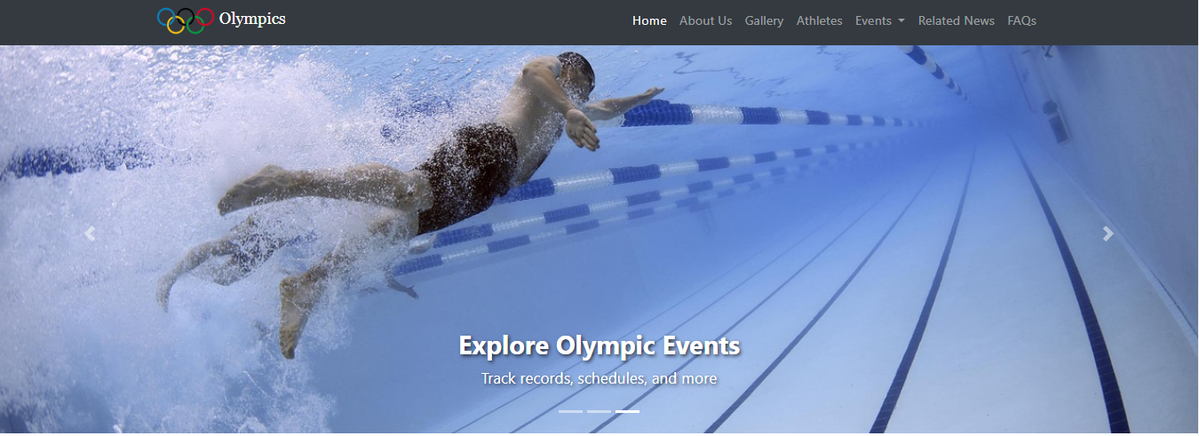4.Home Page

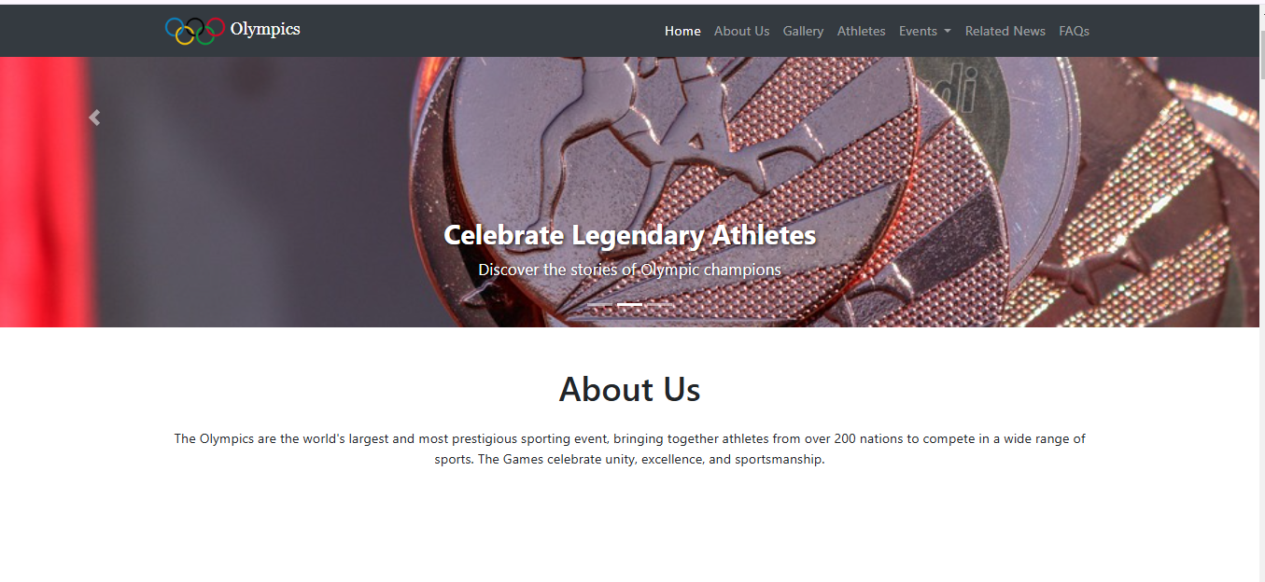

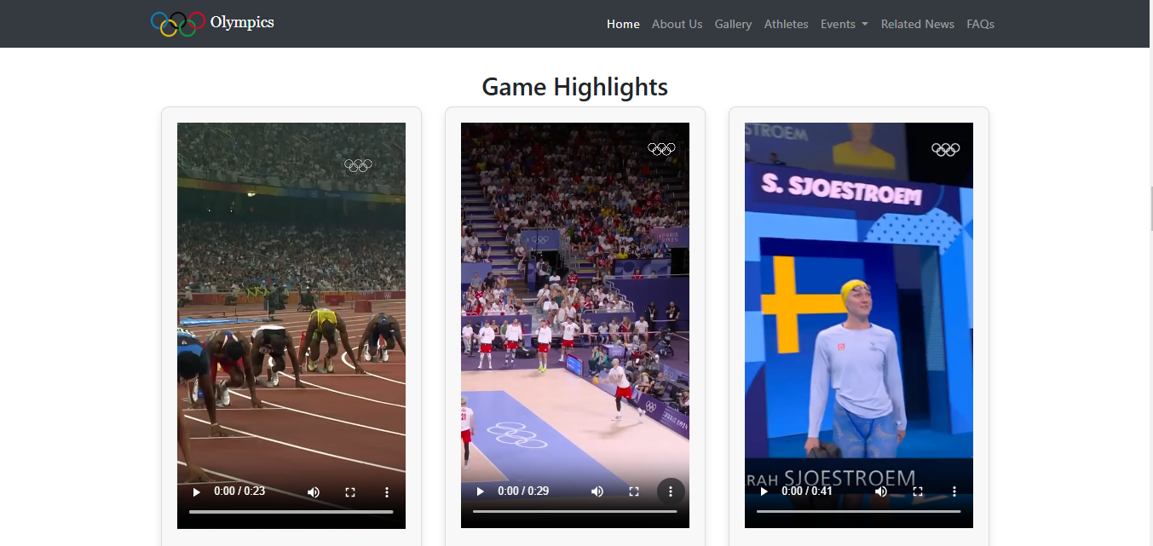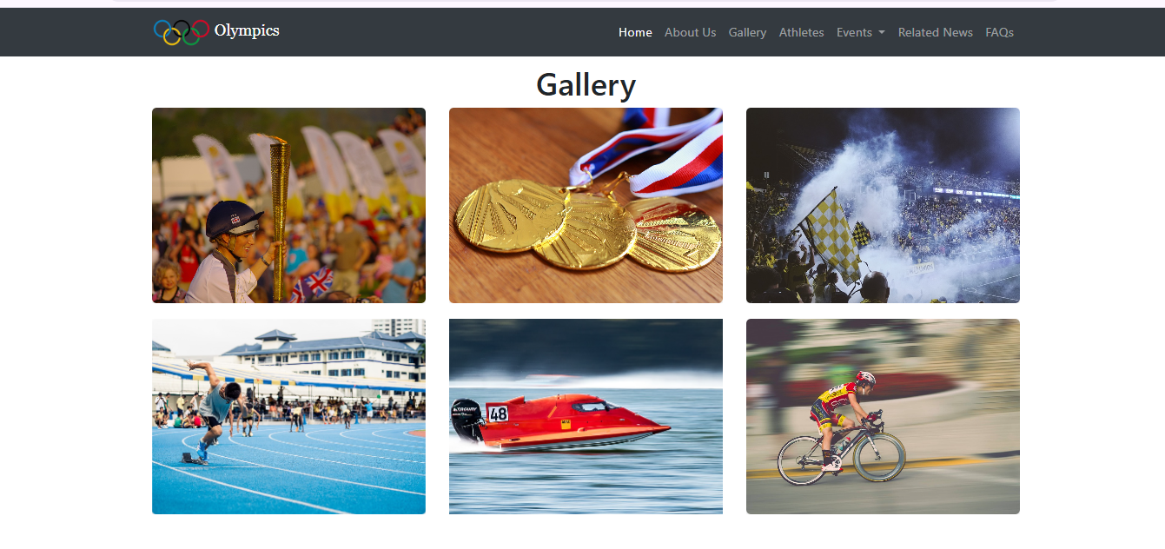

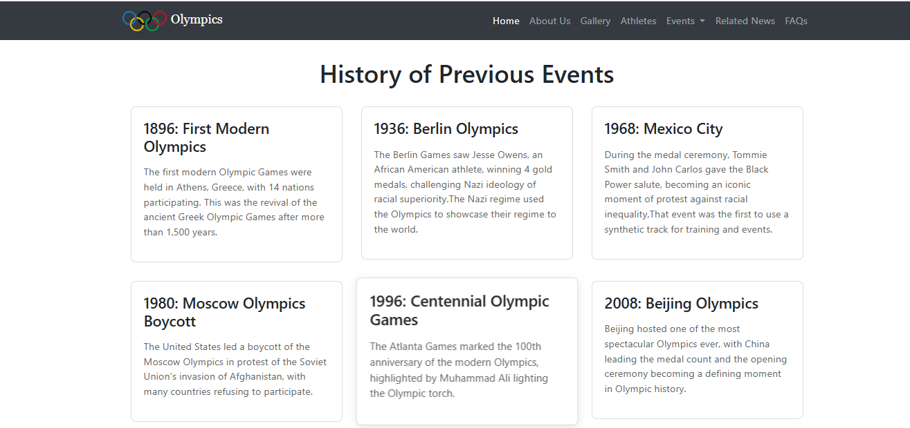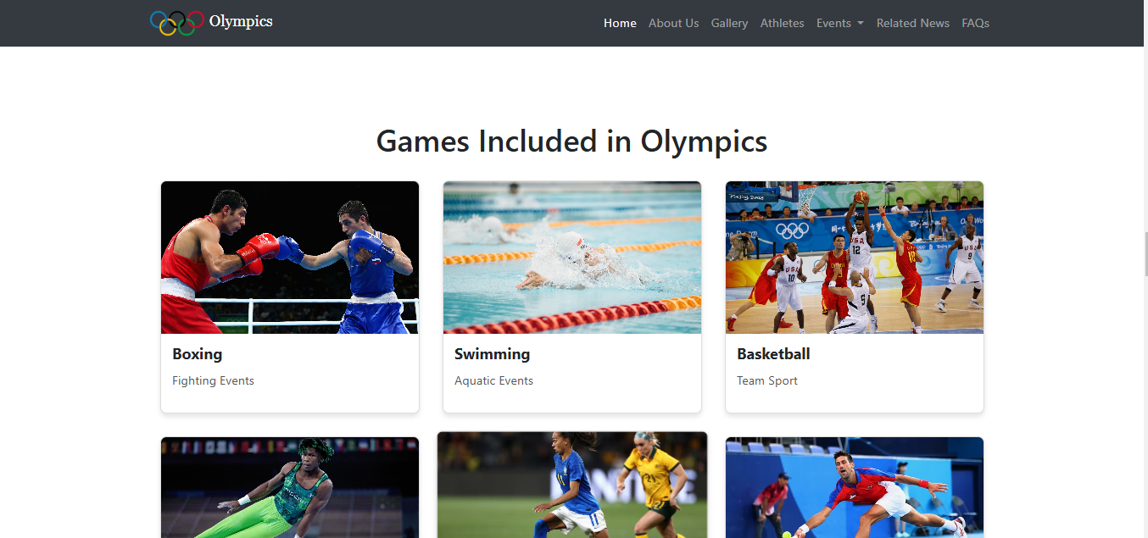

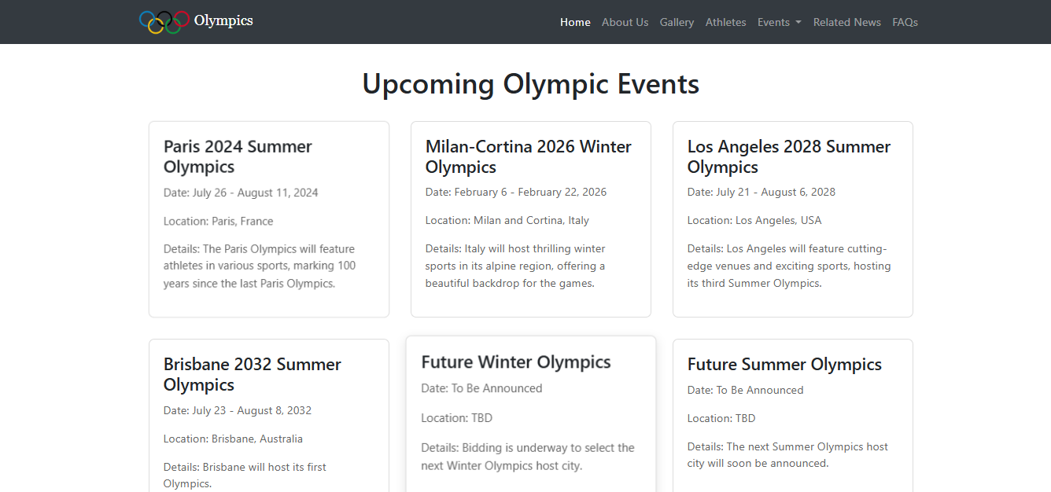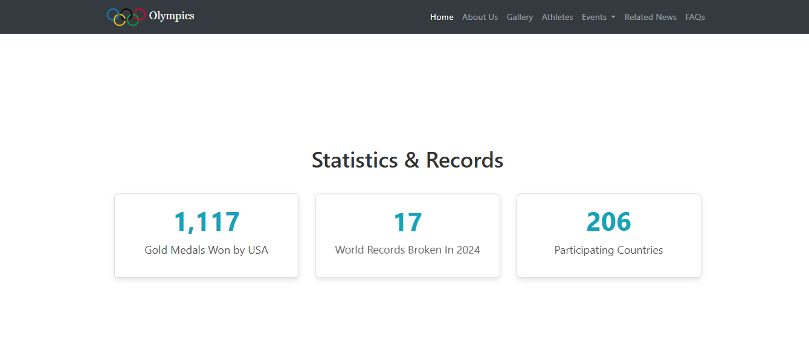

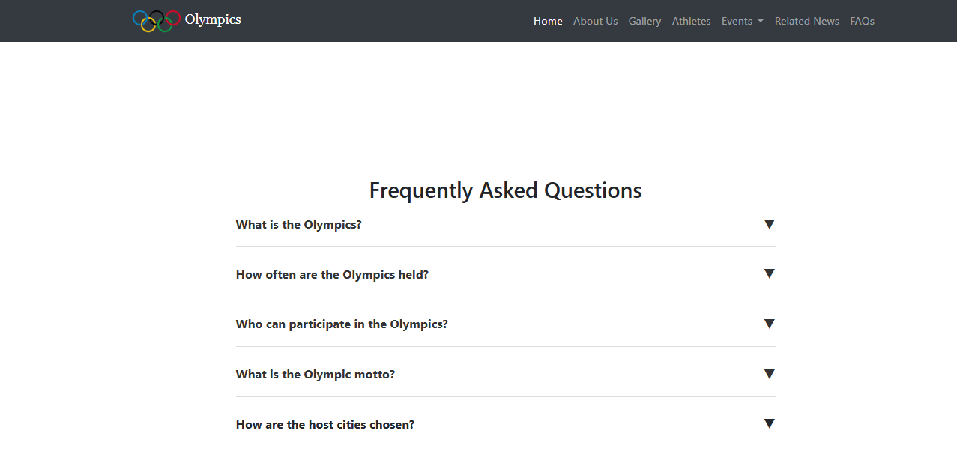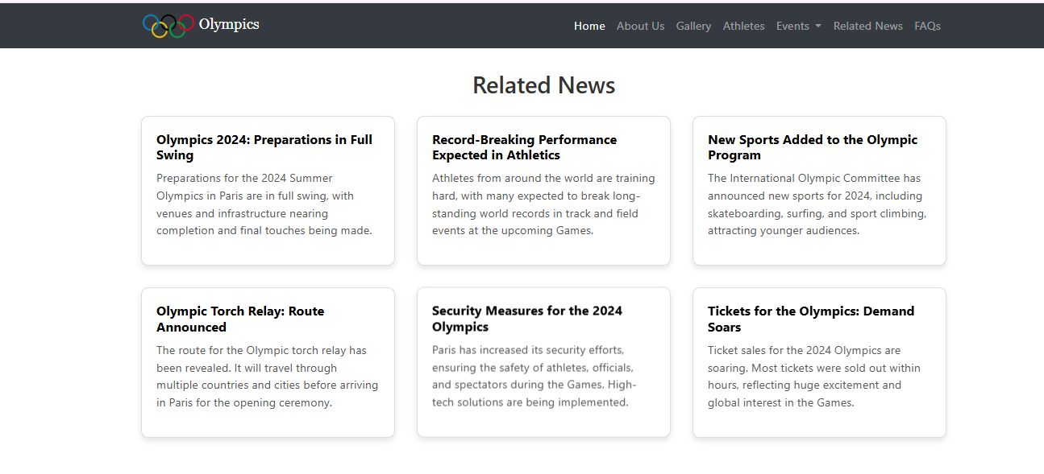

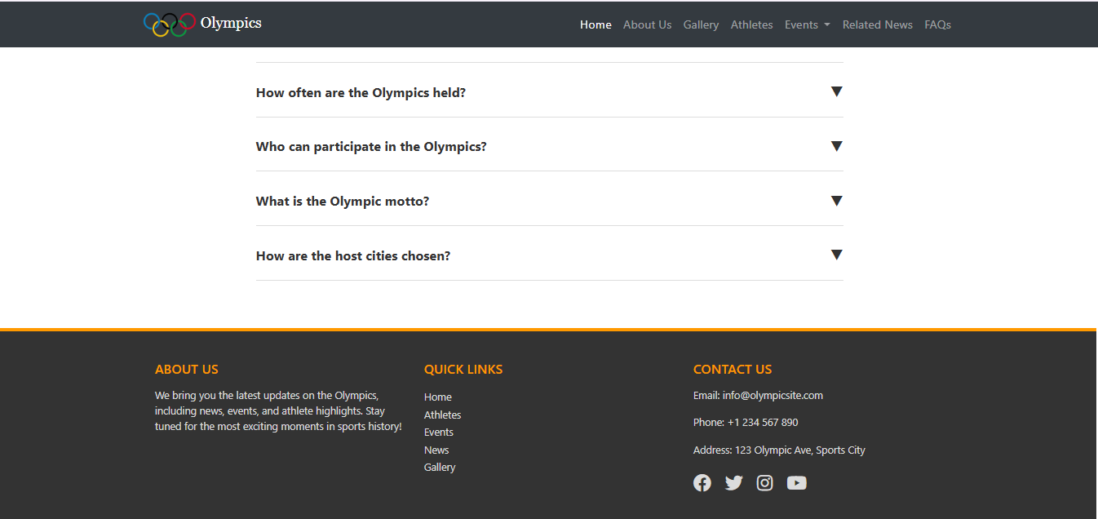

12. Tools

**Hardware/ Software Requirements**

**Hardware/ Software Requirements**

**Hardware**

* A minimum computer system that will help you access all the tools in the courses is a Pentium 166 or better
* 64 Megabytes of RAM or better

**Software *[Either or Combination as per Course/Sem]***

* Notepad/HTML editor/CoffeeCup
* Angular / Angular JS / React / BootStrap
* Dreamweaver / Figma
* MS IE / Chrome / FireFox / Netscape /MS Edge